Lasmigona costata (Rafinesque 1820)
Flutedshell
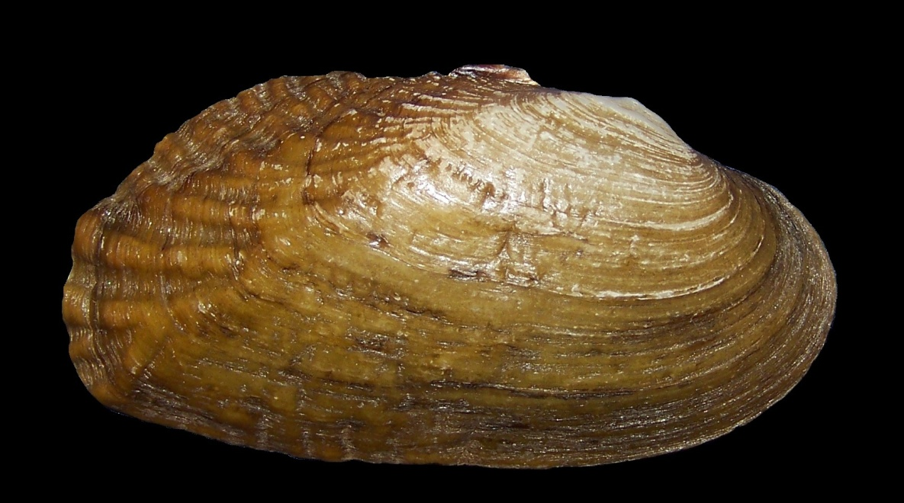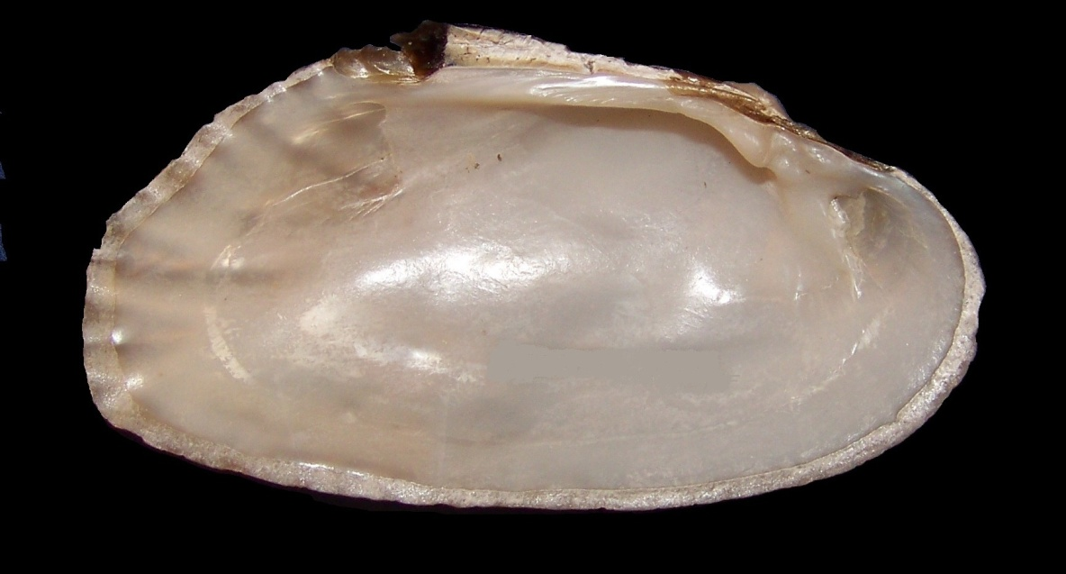
(ASUMZ 1982, length 77.7 mm. South Fork Spring River ca. 0.7 river km upstream of Co. Rd. 80 and ca. 1.0 rd km E of Sturkie, Fulton County, Arkansas.)

KEY CHARACTERISTICS: Shell shape rectangular to rhomboid, elongated, solid, and somewhat compressed; anterior end rather sharply rounded, posterior end obliquely truncated. The posterior ridge is usually well-developed; rounded plications (also referred to as flutes or corrugations) are usually present and directed outward from the posterior ridge toward the posterior and dorsal shell margins. Some Ouachita Mountains drainage populations in Arkansas and Oklahoma have greatly reduced or entirely lack posterior ridge and slope plications. Populations of this morphotype in the upper Chippewa River of Wisconsin also lack posterior plications, and Baker (1928) erected the (currently unrecognized) subspecies Lasmigona costata nuda for the form. The shell disc anterior of the posterior ridge sometimes has plications or weak, irregular wrinkles. The disc may also have growth rest periods indicated by heavy, prominent concentric ridges edged with black. Umbo is depressed and flattened; umbo sculpture consists of 3–4 strongly developed, heavy bars, parallel with the hinge line. The first is simply curved, while the others are more or less double-looped. The left valve has a single heavy, curved, pyramidal, elevated pseudocardinal tooth that is actually two teeth fused into one. The right valve has a heavy, low, somewhat elongated pseudocardinal tooth. Lateral teeth in both valves are reduced to thickenings of the hinge line that may appear as irregular ridges or may be totally absent. The interdentum is narrow or absent. The interdental projection in the left valve is well-developed and may appear fused with the posterior pseudocardinal tooth, and it fits into a depression in the right valve posterior to the pseudocardinal tooth. The umbo cavity is very shallow. The periostracum is yellowish with numerous green rays in young shells; mature shells are a darker yellow or brown, becoming black and rayless in old individuals. The nacre is white, with considerable variation in the amount of cream or salmon present; the area between the pallial line and margin iridescent Mature individuals may attain a length of 190–200 mm.. The animal is dark to pale orange.
DISTRIBUTION: Entire Mississippi River basin from western New York and Pennsylvania west to western Iowa, eastern Kansas, and eastern Oklahoma; Wisconsin and southern Minnesota south to southern Arkansas, Alabama, and Mississippi; Hudson Bay basin in the Red and Winnipeg River drainages, and in the Great Lakes-St. Lawrence basin from southern Lake Huron and its tributaries to the Ottawa River and Lake Champlain (Clarke 1985, Vidrine 1993, Howells et al. 1996, Parmalee and Bogan 1998, Williams et al. 2008, Watters et al. 2009).
DISRIBUTION MAP: Lasmigona costata
Records used for the distribution map are from: Illinois Natural History Survey (IHNS); North Carolina State Museum of Natural Sciences (NCSM); Ohio State University Museum of Biodiversity (OSUM); University of Florida Museum of Natural History (UF).
SIMILAR SPECIES: Lasmigona costata superficially resembles Ptychobranchus subtentus (Fluted Kidneyshell) but P. subtentus shell sculpture is restricted to the posterior ridge and slope whereas L. costata typically has sculpture over the posterior 25-50% of the shell (Williams et al. 2008). Lasmigona costata has rudimentary lateral teeth, but those of P. subtentus are well-developed. Lasmigona complanata (White Heelsplitter) also has plications on the posterior slope and lacks lateral dentition, but it is much rounder in outline, usually with a distinct posterior wing (Watters, et al. 2009). Lasmigona compressa (Creek Heelsplitter) lacks corrugations, has a tongue-like structure on the left valve hinge interdentum, and has lateral teeth (Watters et al. 2009). Lasmigona costata populations with reduced shell sculpturing may resemble Alasmidonta marginata (Elktoe), Strophitus undulatus (Creeper), and Uniomerus tetralasmus (Pondhorn). Alasmidonta marginata is relatively more inflated and has a more sharply angled posterior ridge with much finer plications (sculpturing) than L. costata. Strophitus undulatus is relatively more inflated, has a centrally positioned and broader umbo, a bluntly pointed posterior end, and the lateral and pseudocardinal teeth are reduced with a slightly sinuous hinge line. Uniomerus tetralasmas has a bluntly pointed posterior end and thin but well-developed lateral and pseudocardinal teeth.

HABITAT: Medium-sized rivers to large creeks with moderately strong current and substrate composed of coarse sand and gravel provide the most suitable habitat. In such rivers it is found typically at depths of one meter or less. Lasmigona costata occurs less commonly in large lakes and rivers (i.e., Lake Erie, Mississippi River).
BIOLOGY: Long term brooder (bradytictic), the reproductive period beginning in August with glochidia carried until May (Baker 1928). Two types of glochidia reported: first triangular and strongly hooked; second round, weakly hooked or unhooked with shell grown in marsupium (Watters et al. 2009). It is possible that Lasmigona costata may be facultative parasites able to forego the parasitic stage (Watters et al. 2009), and that the second glochidial type reflects direct development. Glochidia are held in the outer gills and released as a loose mass (Leonard et al. 2014). A host generalist with reported glochidial hosts spanning a broad array of freshwater fish families including Amiidae: Bowfin (Amia calva); Anguillidae: American Eel (Anguilla rostrata); Clupeidae: Gizzard Shad (Dorosoma cepedianum); Cyprinidae: Central Stoneroller (Campostoma anomalum), Goldfish (Carassius auratus), Common Carp (Cyprinus carpio), Whitetail Shiner (Cyprinella galactura), Spotfin Shiner (C. spiloptera), Steelcolor Shiner (C. whipplei), Brassy Minnow (Hybognathus hankinsoni), Common Shiner (Luxilus cornutus), Hornyhead Chub (Nocomis biguttatus), Golden Shiner (Notemigonus crysoleucas), Spottail Shiner (Notropis hudsonius), Mimic Shiner (N. volucellus), Southern Redbelly Dace (Phoxinus erythrogaster), Bluntnose Minnow (Pimephales notatus), Longnose Dace (Rhinichthys cataractae), Creek Chub (Semotilus atromaculatus); Catostomidae: White Sucker (Catostomus commersoni), Northern Hogsucker (Hypentelium nigricans), Bigmouth Buffalo (Ictiobus cyprinellus), River Redhorse (Moxostoma carinatum), Shorthead Redhorse (M. macrolepidotum); Ictaluridae: Black Bullhead (Ameiurus melas), Yellow Bullhead (A. natalis), Brown Bullhead (A. nebulosus), Channel Catfish (Ictalurus punctatus); Esocidae: Northern Pike (Esox lucius); Fundulidae: Northern Studfish (Fundulus catenatus), Blackspotted Topminnow (F. olivaceus); Poeciliidae: Mosquitofish (Gambusia affinis), Mexican Molly (Poecilia sphenops); Cottidae: Banded Sculpin (Cottus carolinae); Centrarchidae: Rockbass (Ambloplites rupestris), Green Sunfish (Lepomis cyanellus), Green Sunfish/Pumpkinseed hybrid (L. cyanellus X L. gibbosus), Pumpkinseed (L. gibbosus), Orangespotted Sunfish (L. humilis), Bluegill (L. macrochirus), Longear Sunfish (L. megalotis), Redear Sunfish (L. microlophus), Smallmouth Bass (Micropterus dolomieu), Largemouth Bass (M. salmoides), Black Crappie (Pomoxis nigromaculatus); Percidae: Rainbow Darter (Etheostoma caeruleum), Fantail Darter (E. flabellare), Striped Darter (E. virgatum), Banded Darter (E. zonale), Yellow Perch (Perca flavescens), and Walleye (Sander vitreus); (LeFevre and Curtis 1910 and 1912, Fuller 1978, Luo 1993, Weiss and Layzer 1995, Hove et al. 1994, Watters, et al. 1998, Watters et al. 1998, Watters et al. 2005, Thompson et al. 2013, Leonard et al. 2014.).
NORTH AMERICAN CONSERVATION STATUS: Currently Stable (Williams et al. In preparation).
ORIGINAL DESCRIPTION: Alasmidonta costata Rafinesque 1820; Rafinesque, 1820: 318, pl. 82, figs. 15, 16.
TYPE LOCALITY: Kentucky River.

SYSTEMATICS: Placed in the nominal subgenus Lasmigona with L. complanata and L. alabamensis (Clarke 1985). There are currently no broad-scale phylogenetic or phylogeographic analyses for L. costata.

Compilers: J.L. Harris, Department of Biological Sciences, Arkansas State University, State University, AR 72467 joharris@astate.edu, A.E. Bogan, North Carolina State Museum of Natural Sciences, Raleigh, NC 27601, arthur.bogan@naturalsciences.org.

References:
Baker, F.C. 1928. The freshwater Mollusca of Wisconsin. Part II. Pelecypoda. Bulletin of the Wisconsin Geological and Natural History Survey. University of Wisconsin. 70(2):i-vi + 495 pages.
Clarke, A.H. 1985. The tribe Alasmidontini (Unionidae: Anodontinae), Part II: Lasmigona and Simpsonaias. Smithsonian Contributions to Zoology, 399. 75 pages.
Fuller, S.L.H. 1978. Fresh-water mussels (Mollusca: Bivalvia: Unionidae) of the Upper Mississippi River: Observations at selected sites within the 9-foot channel navigation project on behalf of the United States Army Corps of Engineers. The Academy of Natural Sciences of Philadelphia, Division of Limnology and Ecology, Report Number 78-33. 401 pages.
Hove, M.C., R.A. Engelking, M. Peteler, and L. Sovell. 1994. Life history research on Ligumia recta and Lasmigona costata. Triannual Unionid Report 4: [24] unpaginated.
Howells, R.G., R.W. Neck and H.D. Murray. 1996. Freshwater mussels of Texas. Texas Parks and Wildlife Department, Austin, TX. 218 pages.
Lefevre, G. and W.C. Curtis. 1910. Reproduction and parasitism in the Unionidae. Journal of Experimental Zoology 9(1):79-115 + 5 plates.
Lefevre, G. and W.C. Curtis. 1912. Studies on the reproduction and artificial propagation of fresh-water mussels. Bulletin of the Bureau of Fisheries. 30(1910):105-201 + 12 plates. [Issued separately as U.S. Bureau of Fisheries Document 756. Reprinted in Sterkiana 47, 48 (1972); 49, 51 (1973); 57 (1975); and 61, 63, 64 (1976)].
Leonard, P., M. Hove, B. Davis, E. Wanner, G. Van Susteren, B. Sietman, M. Berg, A. Handy, A. Thoreen, K. Rod, M. Hanson, R. Pochman, S. Nelson, W. LaMere, and D. Hornbach. 2014. Flutedshell (Lasmigona costata) natural hosts and glochidia release behavior. Ellipsaria 16(4):29-32.
Luo, M. 1993. Host fishes of four species of freshwater mussels and development of an immune response. Unpublished Master's Thesis, Tennessee Technological University, Cookville. 32 pages.

Parmalee, P.W. and A.E. Bogan. 1998. The freshwater mussels of Tennessee. The University of Tennessee Press, Knoxville, Tennessee. 328 pages.
Rafinesque, C.S. 1820. Monographie des coquilles bivalves fluviatiles de la Riviere Ohio, contenant douze genres et soixante-huit especes. Annales Générales des Sciences Physiques 5 (5): 287-322 + plates 80-82.
Thomason, J., M. Hove, B. Sietman, M. Berg, S. Anderson, S. Bump, A. Lindeman, N. Ward, S. Morley, S. Berreth-Doran, and C. Poeschl. 2013. Laboratory trials show Flutedshell (Lasmigona costata) transform on several fishes. Ellipsaria 15(2):19-21.
Vidrine, M. F. 1993. The Historical Distribution of Freshwater Mussels in Louisiana. Gail Q. Vidrine Collectibles, Eunice, LA. 225 pages.
Watters, G.T., S.W Chordas,. S.H. O'Dee and J. Reiger. 1998. Host identification studies for six species of Unionidae. First Symposium of the Freshwater Mollusk Conservation Society, Chattanooga, TN. Program Guide and Abstracts.
Watters, G.T., M.A. Hoggarth and D.H. Stansbery. 2009. The freshwater mussels of Ohio. The Ohio State University Press, Columbus. 421 pages.
Watters, G.T., T. Menker, S. Thomas and K. Kuehnl. 2005. Host identifications or confirmations. Ellipsaria 7(2): 11-12.
Watters, G.T., S.H. O'Dee and S. Chordas. 1998. New potential hosts. Triannual Unionid Report (15): 27-29.
Weiss, J.L. and J.B. Layzer. 1995. Infestations of glochidia on fishes in the Barren River, Kentucky. American Malacological Bulletin 11: 153-159.
Williams, J.D., A.E. Bogan, J. Brim Box, N.M. Burkhead, R.S. Butler, A. Contreras-Arquieta, K.S. Cummings, J.T. Garner, J.L. Harris, R.G. Howells., S.J. Jepsen, N.A. Johnson, T.J. Morris, T.L. Myers, and J.M. Wisniewski. In preparation. Conservation status of North American freshwater mussels. Submitted to Freshwater Mollusk Biology and Conservation.
Williams, J.D., A.E. Bogan and J.T. Garner. 2008. Freshwater mussels of Alabama and the Mobile Basin in Georgia, Mississippi, and Tennessee. University of Alabama Press, Tuscaloosa. 908 pages.

